

**FACULTY OF INFORMATION SCIENCE & TECHNOLOGY**

TDS2111 Data Structures and Algorithms

Trimester 3, Session 2019/2020

Project

Lecturer’s Name: Goh Pey Yun, Lim Kian Ming

**Group Members:**

|  |  |  |
| --- | --- | --- |
| **No.** | **Student ID** | **Student name** |
|  | 1161104063 | Raed Mohammed Omar |
|  | 1171302967 | BIN NOUH ABDULAZIZ FAHAD A |
|  | 1171102561 | Albalawi, Abdulrahman Mohammed O |
|  | 1151103974 | Mohammed owaidah |
|  | 1181301640 | Mohammad Aiman Bin Zulkifli |

**Introduction**

The main objective of the Project of Registration System is to allow students to register subjects online. It manages all the information about Students, Course, Syllabus. The project is totally built at administrative end and the students as well. The purpose of the project is to build a system to reduce the manual work for managing the Syllabus, subject name, credit hour, day, time, venue. This system makes subjects registration easier for the students and administration.

**Registration System**

The Registration System includes operations that creates subjects in the Registration System with their subject name, credit hour, day, time, venue. And Provide general information about the Registration. This specification will be used to implement the Registration System

**Registration System**

**Subject data**

A structure that hold the slot value which is integer data. A string of description of subjects, name, credit hour, day, time, venue. A pointer that points to the next subject on the Registration System list. Also includes an integer value that holds the size of the Registration System

**Class validate**

**Requirements** : ID, Password, Encrypted password database

**Results** : Check the password and ID

**Validity**

**Class admin :**

**Operation 1: update ()**

**Requirement:** valid Registration System’s file name.

**Result:** save the new data.

**Operation 2: display()**

**Requirement:** Existing link list.

**Result:** subject details.

**Operation 3: save()**

**Requirement:** valid Registration System’s file name.

**Result:** Existing link list.

**Operation 4: add_subjects**(string code ,string name, string venue,string day ,int dayn,int time_s,int time_e ,int hour)

**Requirement:** subject code,name ,hours ,,time, venue .

**Result:** adding the subject to the system.

**Class student**

**Operation 1:** add_sub

**Requirement:the subject must available**

**Result:** adding time, hours and venue

**Operation 2:** print_table()

**Requirement**: A valid Registration System’s file name

**Result:** The state of the Registration System’s is saved in a file.

**System Implementation Details**

**Data Structure**

In this system, a linked list approach is used to implement the Registration System. This approach is preferred compared to both stack and queue because each subject is independent of each other and do not need to be arranged in any form or accessed in any sequence. The subject in the Registration System are accessed randomly which give the linked list approach to be the best to follow in this situation.

**Search Algorithm**

The linear search algorithm was implemented in this system. It was sufficient to complete the search without any difficulty.

**Program Screenshots**

**Main Page of the system**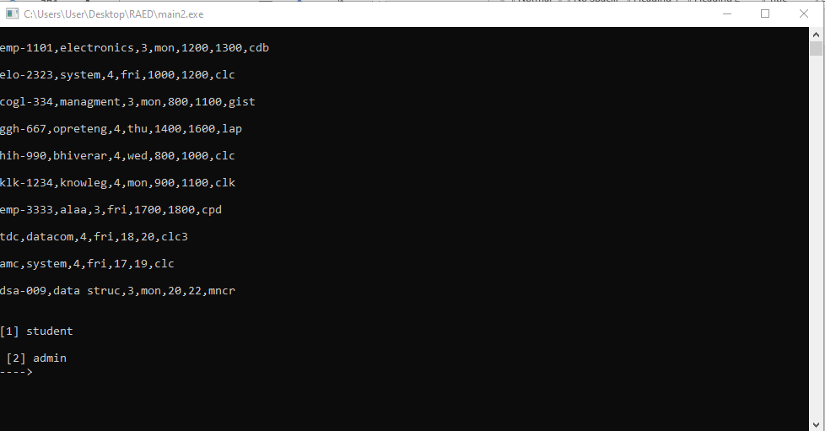

**Main page of the Admin**

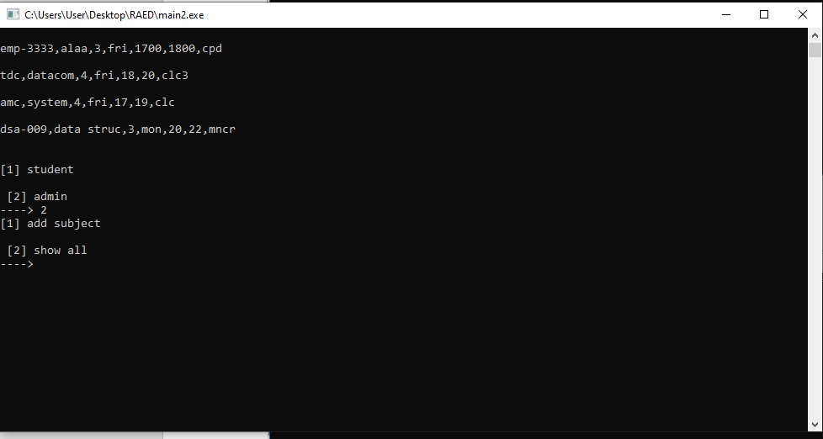

**Adding subject**

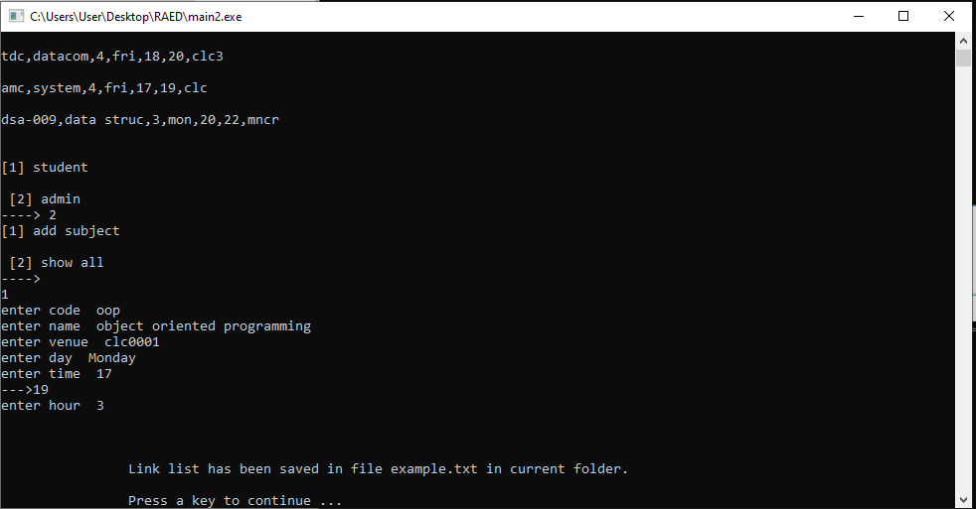

**Show all the subjects**

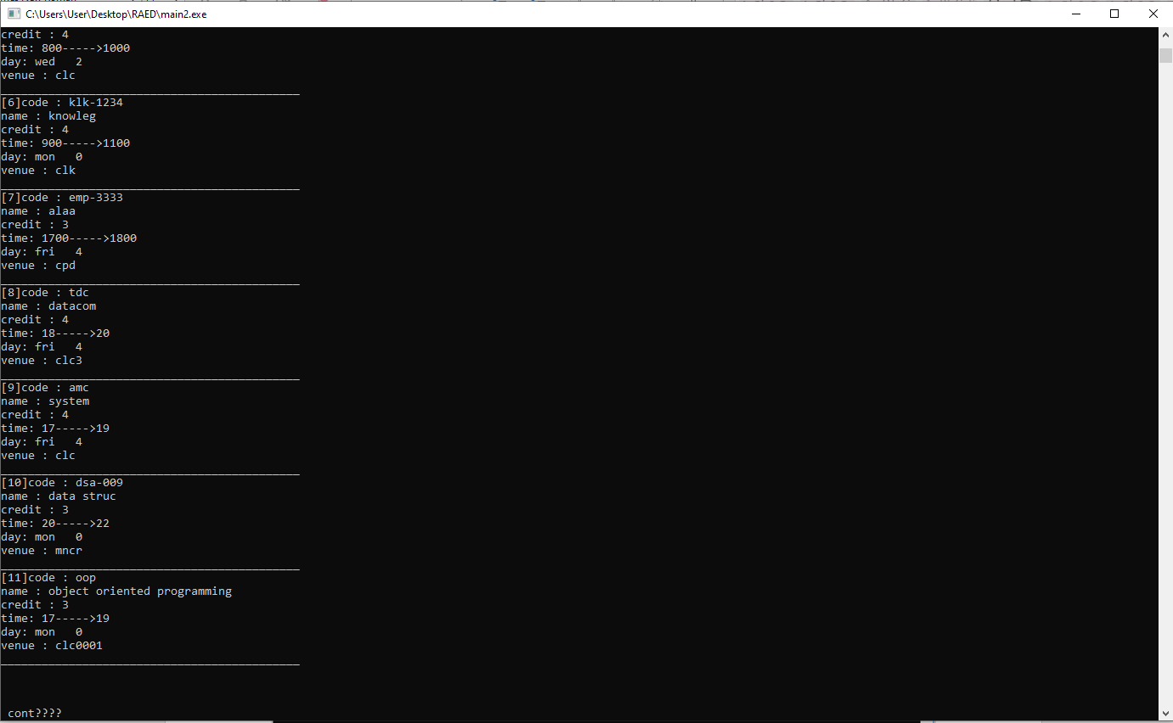

**Student main page**

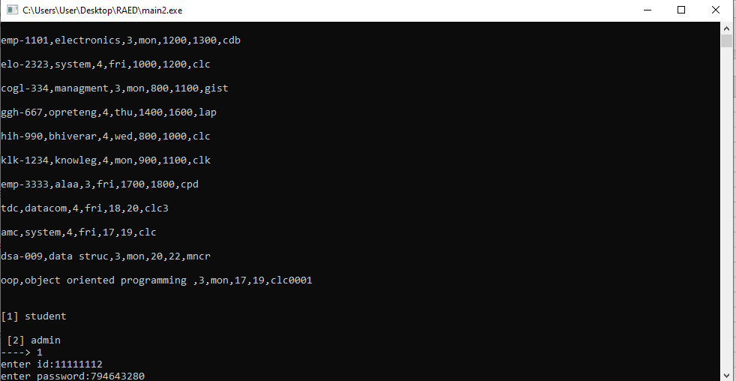

**Available subjects**

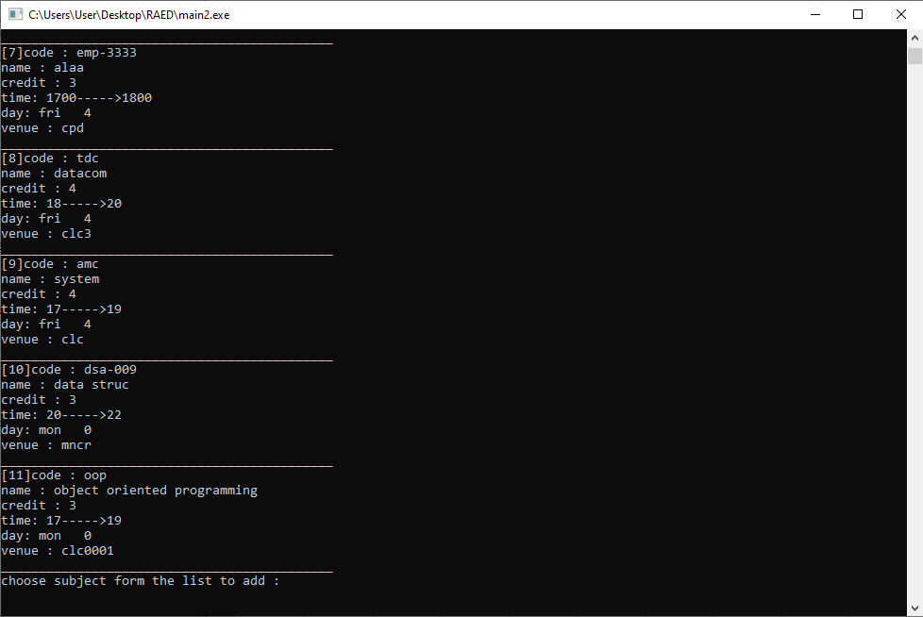

**Show the registered subjects**

